In-House Training Report

On

**Using computational techniques for enhancing oral healthcare**



Submitted to

Amity University Uttar Pradesh

In partial fulfilment of the requirements for the award of the degree of

Bachelor of Technology

In

Information Technology

by

**AAKARSH SHRIVASTAVA(A12405316034)**

**AARUSHI AGRAWAL(A2305316007)**

**PRAKRITI BHARDWAJ(A2305316136)**

**BTECH IT 2016-2020**

Under the guidance of

**MRS. NITASHA HASTEER**

DEPARTMENT OF INFORMATION TECHNOLOGY

AMITY SCHOOL OF ENGINEERING AND TECHNOLOGY

AMITY UNIVERSITY UTTAR PRADESH

**DECLARATION**

We, Aakarsh Srivastava, Aarushi Agrawal and Prakriti Bhardwaj, students of B.Tech IT hereby declare that the project titled “Toothaap” which is submitted by us to Department of Information Technology, Amity School of Engineering and Technology, Amity University Uttar Pradesh, Noida, in partial fulfilment of requirement for the award of the degree of Bachelor of Technology in Information Technology, has not been previously formed the basis for the award of any degree, diploma or other similar title or recognition.

Aakarsh Shrivastava

Aarushi Agrawal

Prakriti Bhardwaj

Date:

**CERTIFICATE**

On the basis of declaration submitted by **AAKARSH SHRVIASTAVA, AARUSHI AGRAWAL AND PRAKRITI BHARDWAJ** students of B.TECH Information Technology, I hereby certify that the project titled “**ORAL HEALTHCARE APP**” which is submitted to Department of Information Technology, Amity School of Engineering and Technology, Amity University, Noida, in partial fulfilment of the requirement for the award of the degree of Bachelor of Technology in Information Technology is an original contribution with existing knowledge and faithful record of work carried out by them under my guidance and supervision.

To the best of my knowledge this work has not been submitted in any part or full for any degree or diploma to this university or somewhere else.

**Mrs. Nitasha Hasteer Date:**

**Dy. Director (Academics)**

**Amity school of Engineering and Technology**

**Amity University U.P**

**ACKNOWLEDGEMENT**

We would like to thank the Head of our Department, Dr. A.Sai Sabitha for her direction in our in-house training as an important aspect of the curriculum and constantly guiding us.

Secondly, We would like to thank our guide Mrs. Nitasha Hasteer under whose guidance we were able to complete our in-house training. We are highly thankful to her for giving us her valuable time and attention and or providing us various research papers which helped in our research.

Our in-house training has been successful, thanks to the support of our respective families and friends. We wish to acknowledge all of them.

Aakarsh Shrivastava

Aarushi Agrawal

Prakriti Bhardwaj

Date:

# ABSTRACT

Great oral care should start at an early age and last throughout your life. It is often seen that people only realize the importance of oral hygiene when they come across some problem and regret of neglecting their oral health .Users can satisfy their need of finding the nearby dentists in the vicinity of their area. The objective of developing an android application is to make users aware using a awareness section with special section made for children . this is done with the help of involvement of MCQ’s etc. This project also has a special highlight towards the child’s need for oral health in the crucial teeth development years of their lives.The purpose of the android application is to provide the user with a platform which can help them maintain a regular and proper oral health care hygiene and provide them with various health tools which can be beneficial to them.

This project is made keeping in mind the above facts in mind. To ease out the problems faced by common people.

Project is designed keeping in mind the common trends and habits related to oral healthcare hygiene regime followed by people in their daily lives. The project is accomplished by

making an Android app named ’Toothaap’ using Android Studio software. The features of the project was divided between the students. After the completion of the individual features those were merged into one Android application.

**Chapter 1 Introduction**

## Motivation

Going through the existing literature we got to know about the increasing risk factor in individual’s oral health not only in India but across the world.

The oral health care is not very prevalent in India due to lack of awareness and facilities. This leads to many oral diseases at a high rate. Percentage of oral diseases in India are: Dental caries (50%, 52.5%, 61.4%, 79.2%, and 84.7% in 5, 12, 15, 35–44, and 65–74 years old, respectively) and periodontal diseases (55.4%, 89.2%, and 79.4% in 12, 35–44, and 65–74 years old, respectively). This percentage shows the two most common oral diseases.

Currently there are many oral healthcare apps which provide various services but not so many as a whole. Hence we have come out with a solution for such problem by making an application which provides multiple features which are not present collectively in a single oral health care app. We also added few new interesting section that will make it a better application. The best advantage of this application would be –

### Increased Doctor-Patient Interaction

The rise of mobile health apps has made the process of contacting top health professionals anywhere in the world. This has led to an increase in doctor-patient interaction. Health apps encourage users to get help if they require it.

#### Encouragement to have good oral hygiene

A large percent of adults with smartphones and tablets have at least one health ‘ToothAap’ app on it. These health apps usually contain a section where users gain awareness about the risks of bad health. This application talks about oral healthcare which gets neglected due to the urban lifestyle and junk eating habits of people. This app provides fun ways to maintain good oral hygiene.

### Easy Information Storage

Such kind of application help the user to store prescriptions on the cloud and helps them to access those prescriptions any time anywhere.

## 1.2 Overview

Toothaap is an android application. It has several components such as:

**1.2.1. Nearby dentists and hospitals finder:**

This feature is made to search nearby dentists and hospitals by using the location of user. It will work on the google maps API. This will help the user to find the location and contact details of the nearby dentists and hospitals. This is a oral healthcare application but hospitals will also searched in these features because major operations related to oral health are majorly performed in the hospitals only.

* + 1. **Database folder:**

For better treatment, it is important to know the case history and medication done in past. Hence this feature will help the user to save his prescriptions, reports etc on the cloud for future reference so that a better treatment can be done if the same problem relapses. Firebase is used for making such feature and the user will able to access these documents by using his credentials on any other device.

**1.2.3. Application login:**

This component of the application will help the user to login through his credential so as to access his account and also his previously saved data. This will be the very first page that will appear when the application will be installed to the device. After entering the credentials, it will not ask for credentials every time.

**1.2.4 Timer feature:**

The ideal brushing time is considered to be 2 minutes. This feature will allow user to select any media file specifically any audio file of his choice that will be played for 2 mins and will stop at after 2 mins. This may help the user to make brushing a fun activity indirectly leading to a better oral healthcare.

**1.2.5 Awareness section:**

This section will contain two sections, one will be the general healthcare section which will help the user to gain general awareness about oral healthcare. The second section will be the child oral health care section that will emphasize on child oral health care. This will help parents to help their children with proper oral healthcare.

**1.2.6 Video song:**

This is a video of approximately 2 minutes that will use animations to educate the user with proper brushing methods and techniques.

* + 1. **Quiz:**

This component is kind of a fun activity that will help the user to increase his oral health knowledge by undertaking this quiz which will have questions related to oral health care. If the user answers correctly the points will be shown in a point tab above the questions.

The purpose of this application is to provide the user with a platform which will help them maintain a good oral hygiene.

## 1.3 Software Development

Software Development is the process of creating a software application (on any platform) to cater to the demands of the client (person/entity who has commissioned the software). A large scale software development project can have hundreds or thousands of software developers working on it. A software application is made in chunks i.e. the entire application is not created or tested at the same time. The steps involved in developing a software application are known as Software Development Model. A Software Development Model can be of many types such as Waterfall model, Iterative model etc.

The generic steps for implementing Software Development Process are given below:

### 1.3.1 Requirement analysis

This is the first step of the Software Development Process. In this step the developer asks the client about what they desire from the outcome of the application. Based on the client’s answer the developer then decides on the type and quantity of the resources and subsequently a rough cost is estimated. Resources will be used in the development of application. The estimated resource(s) may vary if the requirement analysis changes.

**1.3.2 Data Flow diagrams**

Basically data flow diagram is a representation of flow of information inside a system or a software which helps the developer in the implementation of the same. It contains various data inputs, outputs, data stores, various processes and their respective sub processes through which the information moves. It is a similar to ER diagrams present in DBMS where we use standard notations and symbols to show the flow of data inside a system or software.

We use dataflow diagrams to explain the functioning of a software which can not be done easily by using verbal communication or chunks of text. Visualizing a data flow diagrams helps one find out inefficiencies in the existing diagrams and to do changes in it. Dataflow diagram is important to make when new implementation of a project has to be done.

**1.3.2.1 Data flow diagrams level**

DFDs are categorized by levels. Level 0 is the most basic one whereas on increasing the level the dataflow diagrams get more elaborated and complex. It has to be decided before making a data flow diagram that which level will it be. **Data flow symbols and notations**

There are two kind of methodologies for making data flow diagrams

1.Gane and Sarson

2.Yourdon and Coad

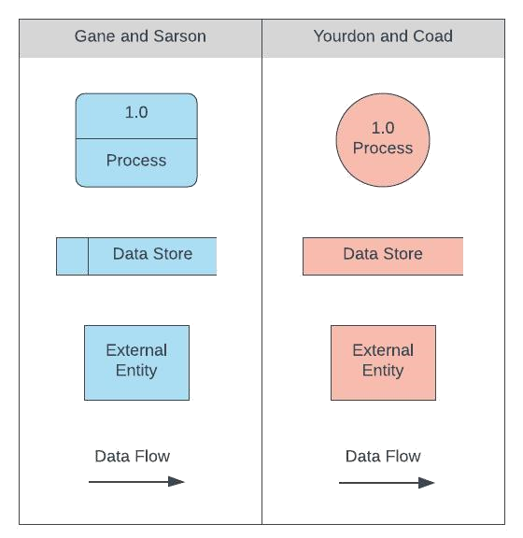

Figure 1DataFlow Symbols [6]

**1.3.2.2 How to create a data flow diagram**

The process can be broken down into 5 steps:

Identify major inputs and outputs in software or application. Every process or system starts with input from an external entity and stops with the output of data to another entity or database. Identifying such inputs and outputs is important for moving further. The DFDs will be built on these elements only. After identifying the elements we should built a context diagram also know as level 0 diagram. In this first we will make a single process node and after that we will connect it to the external entities present in the software. As the context diagram provide very basic info of the software hence we need a level 1 diagram. In level 1 we will show multiple process nodes with the with the external entity to provide a detailed diagram. To enhance the detail of the project we will have to make a level 2+ DFD. Here we have to mention sub processes as well. There is no need to make diagrams beyond level 2+. When our diagrams are completely drawn we will analyze them and try to find out inefficiencies to make them more accurate to proceed further with the software.

**1.3.2.3 Data flow diagrams level**

DFDs are categorized by levels. Level 0 is the most basic one whereas on increasing the level, the dataflow diagrams get more elaborated and complex. It has to be decided before making a data flow diagram that which level will it be.

**1.3.2.3.1** **Level 0 DFDs**

They are also known as the context diagram which give very basic idea about the application. They are also known as the context diagram which give very basic idea about the application.

**1.3.2.3.2 Level 1 DFDs**

They will also give only the general overview but with more details then the context diagrams. They contain multiple process nodes with there connection to external entities.

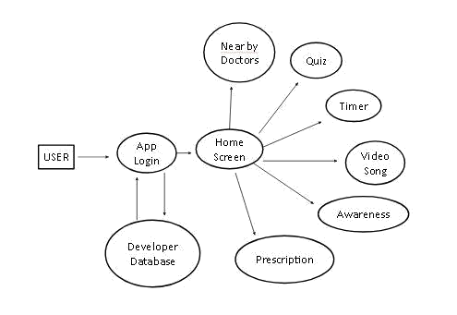

Figure 2 DFD LEVEL 1

### 1.3.2.3.3 Level 2+ DFDs

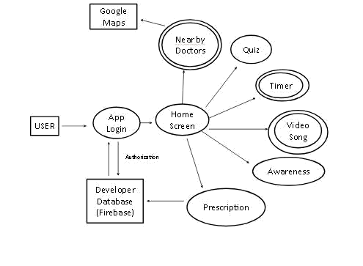

Figure DFD LEVEL 2+

In this the processes are broken further into sub processes for better understanding. We can go beyond level 2+ diagrams but we rarely do so.

**1.3.3 Specification**

In this second step, the developer has to specify the exact application i.e. the required software must be written in a mathematical manner.

* + 1. **Software Architecture**

Software Architecture involves making a representation or basic skeleton of the application. No actual code is written in this part. It is simply a model used to demonstrate how the application will finally work. Software Architecture is akin to making a blueprint. In this step, it is also confirmed that the software meets the present requirement, and all possible future requirements of the client.

* + 1. **Implementation**

Implementation means converting the representation of the software made in the previous step into the actual code. It is a relatively simple task.

* + 1. **Testing**

Software testing is done in stages. As mentioned earlier, the entire software is made in one go. Various components are developed over a period of time by different engineers. These components are tested to check whether the software is running as desired or not.

* + 1. **Documentation**

Documenting the internal working of the software is very important for future purposes.

* + 1. **Maintenance**

Maintenance takes up a large portion of software development. It involves dealing with bug fixes, extending the software to include new functionalities which is essentially new work. Dealing with any errors that arise in the software is also a part of maintenance. Maintenance involves a far greater level of skill than at the initial development stage.

#### Mobile Application Development

Mobile Application Development is the procedure by which applications are created for various wireless mobile devices such as phones and tablets. It falls under the purview of Software Development. These are user-side applications which are typically designed to provide a functionality on a device or to make some task easier to perform. These applications can be developed by a single developer or an entire team i.e. their scale of production varies over a wide spectrum.

To use the features of a smartphone or tablet we rely entirely on applications. Without these apps, which range from the clock telling us the time to a web browser which enables us to connect to the web, our devices would be rendered useless. Applications are also required to utilise the hardware components of a device. They can be made to target specific sensors or attributes of a device. For example, a step counter uses the accelerometer of a device.

### 1.5 Software

#### 1.5.1 Android

Android is an Operating System (OS) based on Linux kernel developed by Google. It is one of the most popular platforms preferred by users all over the world.

Advantages of Android as an Operating System are:

**1.5.1.1 Open Source**

It is an open source platform which means that developers can customise or modify the OS for every individual device as they see fit. This is why the Graphical User Interface or GUI may be different for different devices even though they use the same OS.

* + - 1. **Greater variability of hardware and applications-**

Android devices can have a greater range of hardware performance because of their customisable nature. Several sensors can be added to Android devices to boost their repertoire of features. Because of the addition of increased hardware components, more software applications can be made for using those sensors.

**1.5.1.3 Expansion of memory-**

In addition to the inbuilt or internal storage provided on Android devices, external storage can also be added to them in the form of a microSD card. The microSD card can also be upgraded to include even more storage if desired by the user.

**1.5.2 Android Studio**

Android Studio is an integrated development environment or IDE from Google. It contains tools which enable users to develop applications for Android Operating System. It can be downloaded without any cost and is compatible with all android devices such as Android phones, Android tablets, Android watches, Android TVs etc. Features of Android studio are:

* Easy to use UI

The user interface or UI of Android Studio is fairly simple to use. It can be used by both novice app developers and professionals. The UI very clearly lays out all the features available to the user. Several templates exist for the user to choose from such as Java class, C/C++ class, various Activities like Navigation Drawer Activity, Empty

Activity etc. for designing the visual layout of an application.

* Continuous Integration

Android Studio is based on the model continuous integration. As mentioned earlier no software is developed in one go. It is developed in chunks which are then put together. The different parts of the code are made by different people, so if these parts were to be incorporated together before being checked individually then an error occurring in one such part or snippet of code would now affect the entire application. So, because of continuous integration the code is checked as soon as it is logged in by a developer. If any error occurs it is recognised immediately and dealt with.

* Performance Tools

Performance Tools in Android Studio determine how an Android Application Package File (APK) is functioning. Performance tools let the developer know about the extent of success of their APK. They analyze the performance of all the components of Android Studio.

* Memory Tools

Another important set of tools in determining an application’s performance are Memory Tools. Memory tools provide information about the amount of RAM used during various stages of the application execution.

The device battery is also analysed by memory tools to determine if the application will drain more battery than necessarily required.

It also tells the developer where Garbage Collection occurs.

#### 1.5.3 Java

Java is a very popular, widely-used high level programming language or HLL. What makes java so popular is the fact that it can run on any machine which has Java Virtual Machine or JVM. Most of the machines do have JVM. The coding aspect of Android Studio is based on Java.

Unlike C++, Java uses the concept of continuous integration as well in which syntax errors are detected automatically without having to run the compiler first.

The source code of a Java File is saved with a ‘.java’ extension which is then converted into a bytecode or intermediate code with the extension ‘.class’. The bytecode can then be executed by Java interpreter.

Features of Java are given below-

* Simple

Java is fairly simple to use. This is due to the fact that its syntax is based on C++. So, a programmer with intermediary knowledge of the C++ syntax can also operate on

Java.

* Platform Independent

It is platform independent due to the existence of bytecode. Bytecode allows Java programs to run on any Operating System as long as they contain JDK.

* Object Oriented

In an object oriented environment we use classes which are a collection of methods and data. Objects are then made. These objects are used to provide a reference to the classes so that their data and methods can be accessed. Objects basically act as messengers in an object oriented environment. They pass messages to each other and also to the class they are connected to.

Features of Object Oriented Programming Language are :

* + Polymorphism

* + Inheritance

* + Object

* + Class

* + Abstraction

* + Encapsulation

* Secure

Java is more secure than other programming languages because it uses it’s own runtime environment. On the other hand C++ uses the Operating System’s runtime environment. Therefore, in case of Java no application running in the OS memory can affect it’s execution in anyway.

#### 1.5.4 HTML

HTML or HyperText Markup Language is the fundamental language used to create webpages. Every webpage is built upon HTML. HTML uses markers or tags to organise various components on a webpage such as headings, images, plaintext etc. into a proper layout. HTML tags are enclosed within opening and closing angular brackets. It is these tags which determine the final look or output of the page. Every HTML webpage contains links known as hyperlinks to several other pages. Scripts from different languages such as JavaScript and CSS can be embedded into an HTML page.

#### 1.5.5 Java Development Kit

Java Development Kit is is an implementation of either Java Platform Standard/ Enterprise/ Micro Edition platforms released by oracle for Java developers on Solaris, Linux, macOS or Windows. A Java Development Kit has its own Java virtual machine and some other features to complete a java application. It has been the most widely used SDK by far. It is an extended subset of software development kit (SDK). It includes "tools for developing, debugging, and monitoring Java applications". Oracle now recommends to use Java Development Kit term to refer to Java SE Development kit.

#### 1.6 Application Programming Interface

An API is set of definition and protocols for application software building. In simpler words it is a set of well defined methods to ease development of a computer programmer by providing all building blocks at one place which can later be put together by the programmer. An API may be web bases, OS based, DB based, etc. A GUI makes it easy for users, while API makes it easy for developers to make the app.

#### 1.6.1 Intent

Intent gives the description of the operations that are to be performed. It provides facility for doing a late runtime binding b/w the code and different applications. The most important function of intent is to launch activities. In other words it connects different activities. Intent can be used with :

1. StartActivity to launch activity.
2. BroadcastIntent to send to BroadcastReceiver.
3. StartService to communicate with background services.

The main parts of an intent are :

1. Action
2. Data

#### 1.6.2 Activity

Activity is a single focused thing that a user can do. Activities interact with user to give the user a better experience. Activities also interact with one another. They are often displayed to a user in full screen window, while they can also be displayed in other ways like floating window or embedded activity that is an activity inside an activity.

#### 1.6.2 WebView

As the name suggests webview is a display that shows web pages. This is a way where you can roll your own web browser or display some contents available online. I t uses WebKit rendering engine to show web pages/content.

##### 1.6.3 Listener

Listener class gives set of callback functions that someone can override in a subclass to revert on events released by Controller object. Event listener gives interfaces that handle events. Java consists of many event listeners. Each method of event listener method has single argument.

# Chapter 2 Methodology

## 2.1 Steps taken to build ‘Toothaap’

### 2.1.1 Usability of the Application

Before creating any application a developer must ask themselves why they are building that app in the first place. Every app must set out to solve a problem which the users can benefit from.

There are pre-existing applications in the market which provide few of the features that will be present in the application but no app gives the user the opportunity to use all above features in one application. Hence these can be an application in with great usability in near future.

### 2.1.2 Architecture of the application

Application design involves making a basic framework of the app without writing any actual code for it. It is similar to the ‘Software Architecture’ step involved in Software Development. The layout is designed using XML files available in Android Studio. An appropriate layout design is selected from the different options Android Studio has to offer. In this case ‘RelativeLayout’ was chosen.

These XML files provide the reference of various Buttons, Plain Text Fields, Textboxes to the activity they are associated with.

### 2.1.3 Writing the code in Java Files

#### 2.1.3.1 Reference components from XML file

After forming the required layout for an activity, the logic for the corresponding Java code was written. The very first thing to be done is to provide references of various Textboxes, Plaintext Fields, Number Fields, Buttons, TextViews etc. in the Java file from it’s XML file. This is done to access those components. If these components were not referenced then we would not be able to enter values or get values from them.

#### 2.1.3.2 Writing code for the main logic

After forming references we finally get down to the logic of an activity. Now logic here means the part of code which is used to get the final result that we want. For example, if we take a look at the nearby dentists activity which uses google API and there will be a change in logic done so that it searches only nearby dentists and hospitals.

Now that the logic has been written in the Java code, the coding portion of an activity is almost complete.

#### 2.1.3.3 Add intent to make activity reachable

The final step is to make sure that the activity is reachable from the Launcher Activity. There are several ways to do this. The most common one is to add a button on the Home Screen or the launcher activity which when clicked will take the user to that particular Activity. This linking between two activities is done by using an intent in the activity from where the user has to go to another page, This is most commonly the Home Screen.

#### 2.1.4 Testing Activity

In the Software Development section above it is mentioned that every component of an app must be tested individually rather than testing the entire app all at once. This is advised because if the application is tested in discrete units then an error or bug in one unit will not affect any other units.

On the other hand, if the code for the entire application is written and then all the activities are tested at the same time, then if an error occurs the developer will find it difficult to gauge which activity is generating the error. For testing an activity or application, there are two ways:

### 2.1.4.1 Using an emulator

Android Studio provides an option to download an emulator. The user can select the API level and the OS version which he/she would like to use. When an emulator is used there is no need to connect any external device to your computer. A virtual device is created on the computer and the app or activity starts running once the ‘Run’ button is hit. A disadvantage of using an Emulator is that that it takes up a lot of space in the computer’s RAM. So, if one is working with a limited amount of memory available to them then using an emulator should be avoided.

### 2.1.4.2 Connecting an Android Device

The second method to test an app is by connecting an Android device to your computer via a USB cable. It should be kept in mind that for systems running on Windows OS, the appropriate Android device drivers have to be installed before the application will be able to run. Once the device drivers have been installed correctly, connect your device and hit ‘Run’. Your application will run on your device. This method is better as no excessive additional memory space is required by it.

**2.1.5 Resolve errors**

After having tested the activity, errors are resolved (if any) in the respective activity. This method of handling errors activity by activity makes the task so much more convenient.

### 2.1.6 Repeat above steps

### The steps mentioned above must be repeated for every activity. Continue until all your activities have been tested.

Then finally, compile all your activities and run the entire app as a whole.

**CHAPTER 3 RESULT AND OUTCOMES**

**3.1 RESULTS**

**Features of the app:**

**3.1.1 Login page**

Whenever the app will be installed for the very first time on the device then a login page will appear which will ask for the credentials from the user or will ask the user to signup.

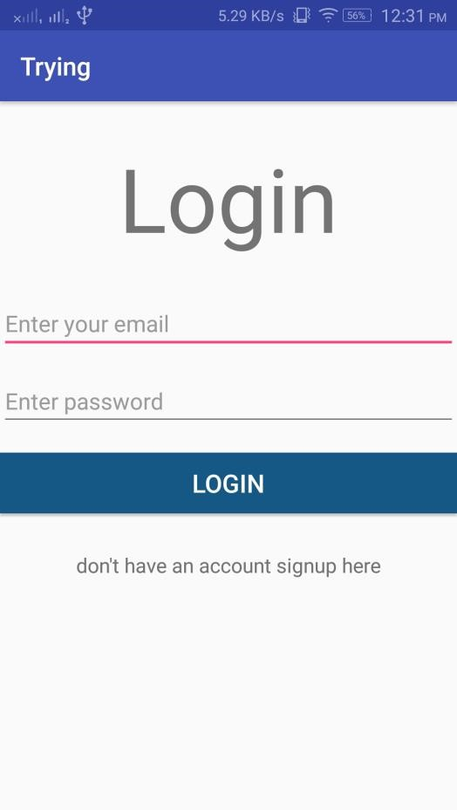

Figure 4Login Activity

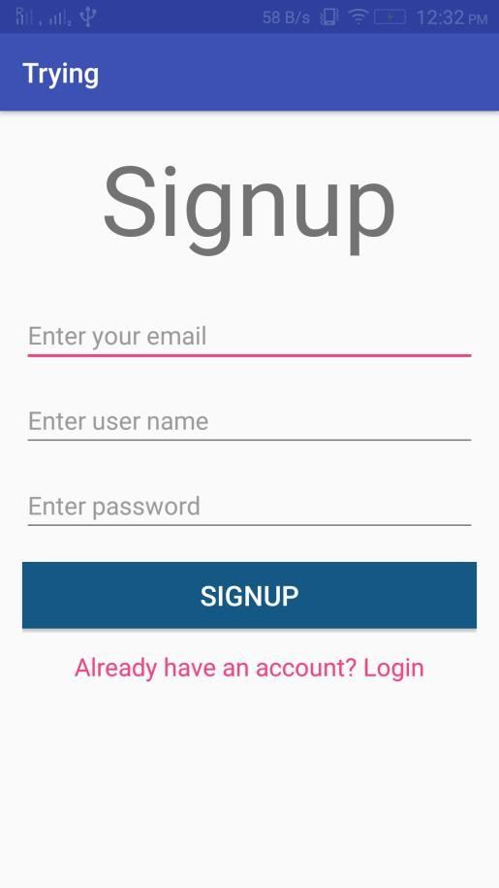

Figure 5 Signup Activity

### 

#### 3.1.2 Nearby dentist/hospital finder

The user will have to turn on his GPS feature so that the application and fetch the location of device and can find the nearby dentists on the google API.

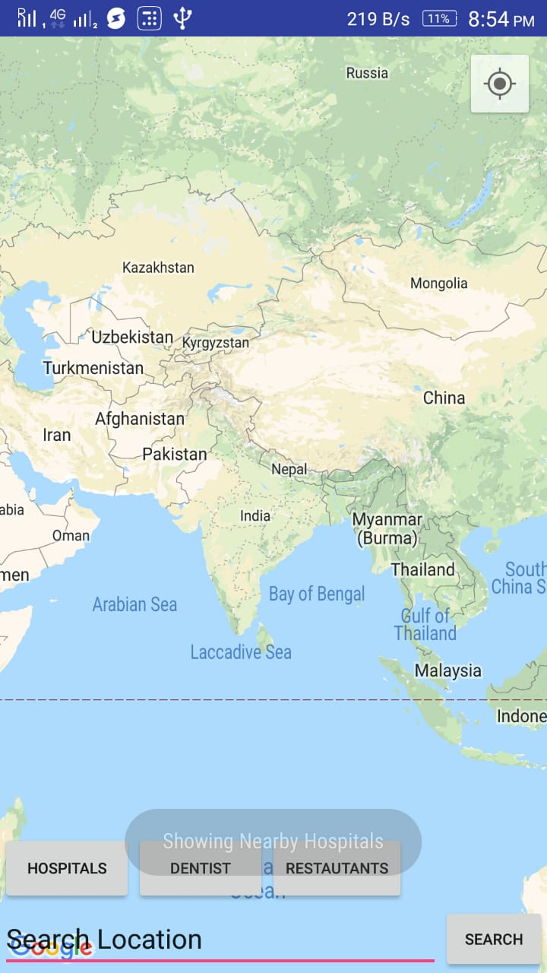

Figure 6 Maps Activity

#### 3.1.3 Awareness section

This activity displays two sections for awareness. One for general awareness and one section specifically emphasizing on child oral health care.

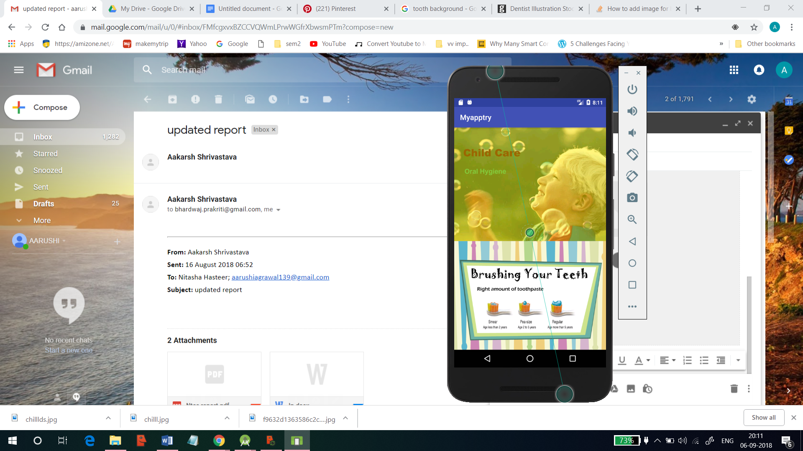

Figure 7Awareness activity

**3.1.4 Timer**

User can set a timer of two minutes for optimum brushing time. Along with the time running, an audio song will be played to let the user know when two minutes are over.

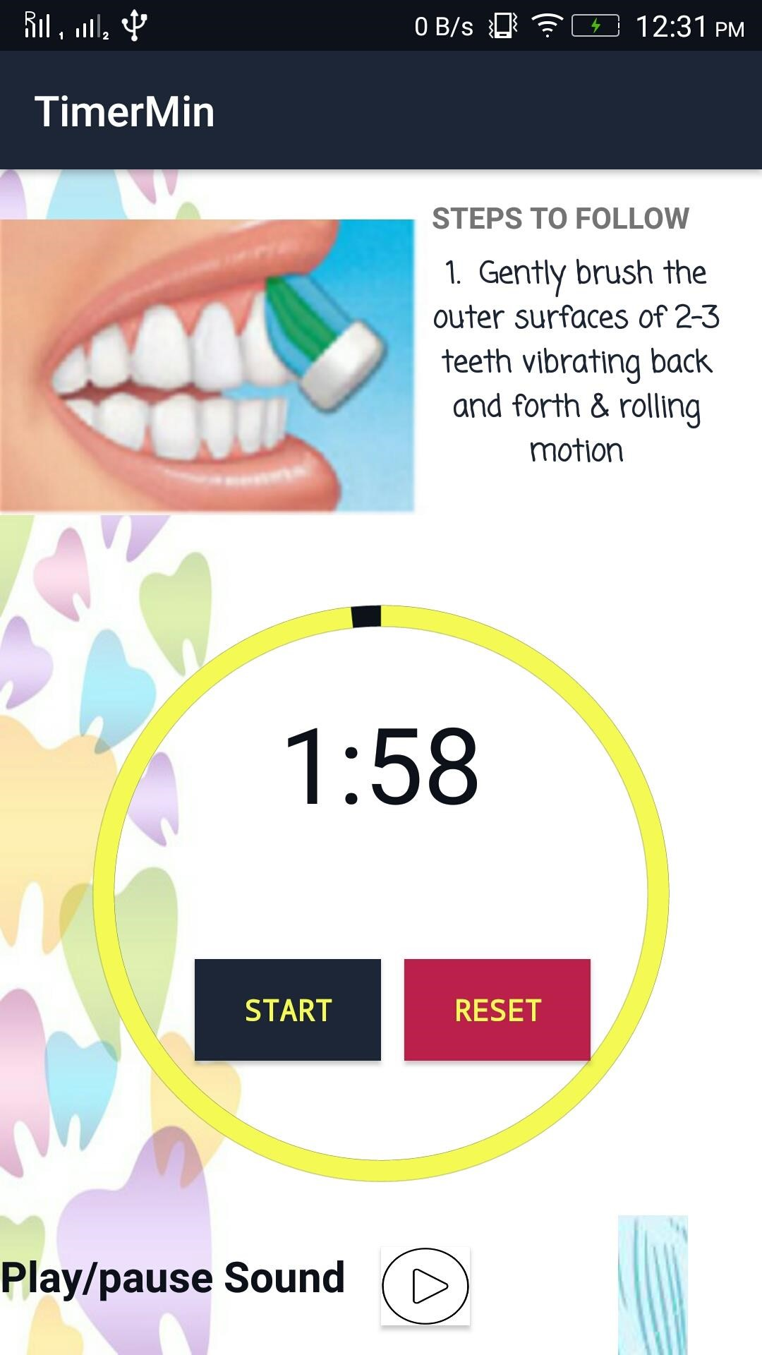

Figure 8 Timer Activity

#### 3.1.5 Database Handler

User can upload prescriptions from gallery or directly capture the image of the prescription. The user can also view uploaded prescriptions when required.

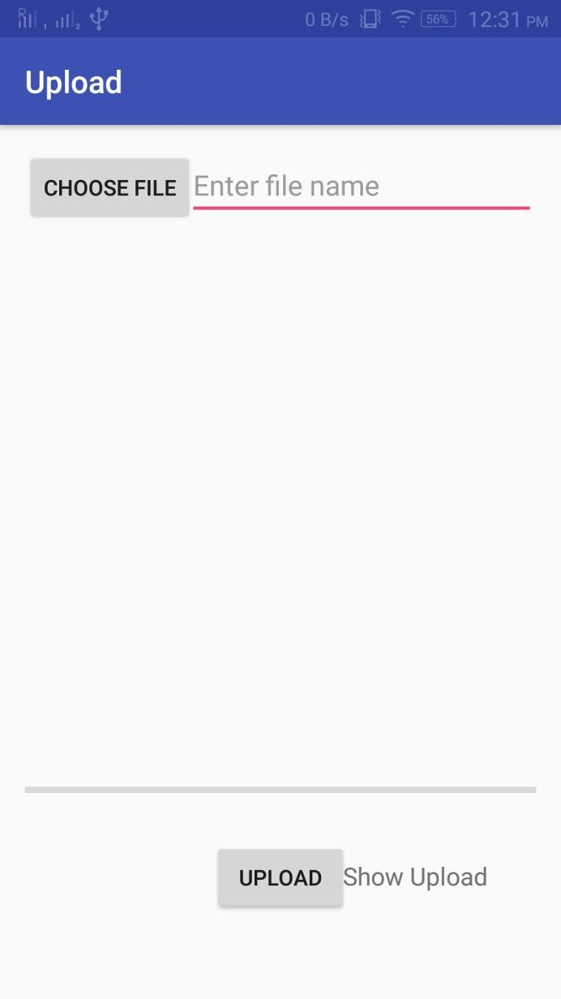

Figure 9 Upload Activity

#### 3.1.6 Video song

A few options to play video songs are given to the user. Each song is played for two minutes approximately. This feature is mainly for children to enjoy brushing while learning proper brushing skills.

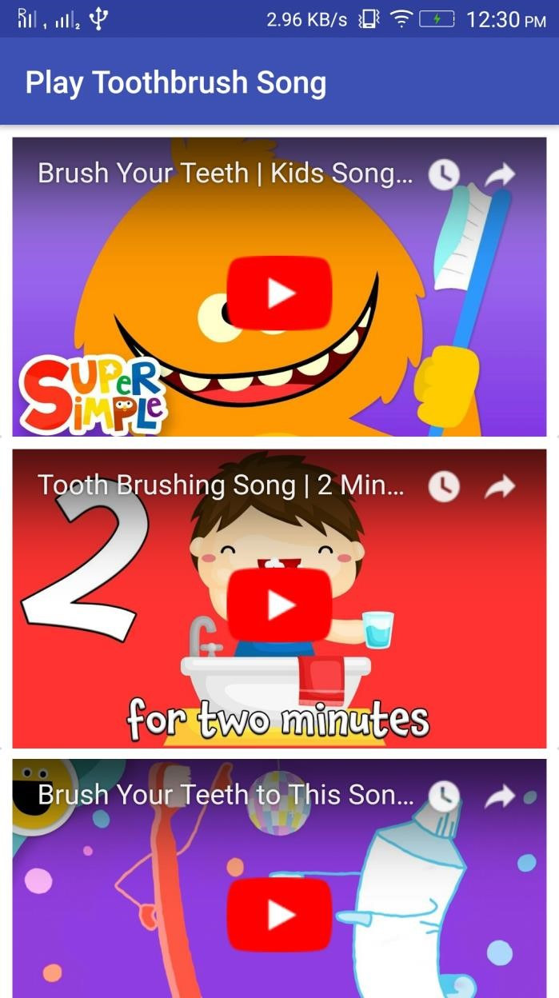

Figure 10 Video Song

**Chapter 4 Solutions provided by the app:**

There is an awareness section in the app that focuses on providing awareness to the users. Locate nearby dentist and hospitals is another feature that guides the user to the desired destination without any chaos. Timer is a feature of the app that allows the users to brush for optimum brushing time i.e, two minutes. Quiz is yet another feature providing information to the users regarding oral knowledge in an attractive game manner that has a scoreboard showing the points scored by the player based on the number of correct answers.

Software Limitations:

* Minimum android version required to run the app is android jellybean 4.1

* Net connection is required to play video songs, location and upload

prescriptions.

* Users can upload and view prescriptions but there is no such option for X-ray

reports.

* Users can locate dentists’ clinics and hospitals but cannot fix an appointment with the dentist.
* There is a read-only awareness section for oral health and child care but expert guidance is missing thus making it a one-way communication process.

Hardware Limitations:

* RAM size:1 GB

* Internal storage: approx. 100 MB

**CHAPTER 5 CONCLUSION**

New mobile oral healthcare apps are being created every day. These applications are the future of oral health care and hygiene. Oral Healthcare apps put the control of medical decisions into the hands of the user or the patient. Because of these apps, people nowadays have a greater understanding of proper brushing, flossing and mouth washing along with their optimum time.

Patients will gain awareness and control over their oral health decisions. They won’t have to rely solely on the dentist to provide them with advice. People might even be able to diagnose themselves.

Mobile oral healthcare applications are bound to change the oral healthcare landscape that is prevalent for some kind of disease.

## 5.1 Limitation of this application

### ● Lack of privacy

A lot of mobile health apps take user information such as their name, age, email address etc. This information taken by the app database may or may not be secure. Moreover, most of these apps require the phone GPS to be enabled which can be used to track a user’s movements, thus completely evading their privacy.

### ● No approval by a recognised medical agency

Mobile health apps are rising exponentially, but there is no approval given to them by any recognised authority such as the FDA.

**5.2 Future scope**

In future we can expect an application which uses artificial intelligence to detect oral health problems like cavities, plaque etc so the user can detect the condition and communicate the doctor for immediate treatment.

Let’s hope for a healthier and smarter future!

## 

## REFERENCES

[1] Qi, X.Q. Report of the third national oral health brushing game with 16 children (aged 6 to 10) using Wizard of Oz.The tests were carried out survey in China. People’s Medical Publishing House, Beijing, China, 2008. either individually or collaboratively under personal.

[2] Saragih, Sornauli, “Hubungan Kualitas Pelayanan dan Kepuasan Pasien dengan Kunjungan di Balai Pengobatan Gigi Puskesmas Kota Pekanbaru,” Medan: Tesis Pasca Sarjana Administrasidan Kebijakan Kesehatan Universitas Sumatra Utara, 2009.Saragih, Sornauli,“Hubungan Kualitas Pelayanan dan Kepuasan Pasien dengan Kunjungan di Balai

Pengobatan Gigi Puskesmas KotaPekanbaru,” Medan: Tesis Pasca Sarjana Administrasi dan Kebijakan Kesehatan Universitas Sumatra Utara, 2009.

[3] V.Krishnaiah “Diagnosis of Lung Cancer Prediction System Using Data Mining Classification Techniques” International Journal of Computer Science and Information Technologies, Vol. 4 (1), 39 – 45 [www.ijcsit.ComI](http://www.ijcsit.com/)SSN:0975-9646, 2013. Zakaria Suliman zubi “Improves Treatment Programs of Lung Cancer using Data Mining Techniques” Journal of Software Engineering and Applications, 7, 69-77, February 2014.

[4] Chang, Y., Lo, J., Huang, C., Hsu, N., Chu, H., Wang, H. Chi, P., and Hsieh, Y. 2008. Playful toothbrush: ubicomp technology for teaching tooth brushing to kindergarten children. In Proc. of CHI '08. ACM, 363-372 Chang, Y., Lo, J., Huang, C., Hsu, N., Chu, H., Wang, H., Chi, P., and Hsieh, Y. 2008. Playful toothbrush: ubicomp technology for teaching tooth brushing to kindergarten children. In Proc. of CHI '08. ACM, 363-372.

[5] https://www.lucidchart.com/blog/data-flow-diagram-tutorial

[6] Kang-Hwi Lee, Jeong-Whan Lee, Kyeong-Seop Kim, Dong-Jun Kim, Kyungho Kim, Heui-Kyung Yang, Keesam Jeong, and Byungchae Lee. 2007. Tooth brushing pattern classification using three-axis accelerometer and magnetic sensor for smart toothbrush.In Engineering in Medicine and Biology Society, 2007. EMBS 2007. 29th Annual International Conference of theIEEE. IEEE, 4211–4214.